* **Total Loan Applications**

select count(id) as 'Total Loan Applications'

from financial_loan;

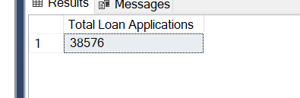

* **MTD loan applications**

with cte as

(select max(year(issue_date)) as l_year ,max(month(issue_date)) as l_month

from financial_loan)

select count(id) as 'MTD Loan Applications'

from financial_loan f join cte

on month(issue_date) = l_month and year(issue_date) = l_year

* **PMTD loan applications**

with cte as

(select max(year(issue_date)) as l_year ,max(month(issue_date))-1 as p_month

from financial_loan)

select count(id) as 'PMTD Loan Applications'

from financial_loan f join cte

on month(issue_date) = p_month and year(issue_date) = l_year;

* **MoM loan applications**

with cte as

(select month(issue_date) as 'Month',count(id) as 'Total_Loan_Applications'

from financial_loan

group by month(issue_date)

)

select *,

1.0 *(Total_Loan_Applications -

lag(Total_Loan_Applications,1,Total_Loan_Applications) over(order by Month)) / lag(Total_Loan_Applications,1,Total_Loan_Applications) over(order by Month) * 100 as 'MoM_Growth'

from cte;

* **Total Funded Amount**

select sum(loan_amount) as 'Total_Funded_Amount'

from financial_loan;

* **MoM Funded Amount**

with cte as

(select month(issue_date) as 'Month',sum(loan_amount) as 'Total_Loan_Amount'

from financial_loan

group by month(issue_date)

)

select *,

1.0 *(Total_Loan_Amount -

lag(Total_Loan_Amount,1,Total_Loan_Amount) over(order by Month)) / lag(Total_Loan_Amount,1,Total_Loan_Amount) over(order by Month) * 100 as 'MoM_Growth'

from cte;

* **Total Amount Received**

select sum(total_payment) as 'Total_Amount_Received'

from financial_loan;

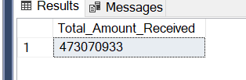

* **MoM Amount Received**

with cte as

(select month(issue_date) as 'Month',sum(total_payment) as 'Total_Amount_Received'

from financial_loan

group by month(issue_date)

)

select *,

1.0 *(Total_Amount_Received -

lag(Total_Amount_Received,1,Total_Amount_Received) over(order by Month)) / lag(Total_Amount_Received,1,Total_Amount_Received) over(order by Month) * 100 as 'MoM_Growth'

from cte;

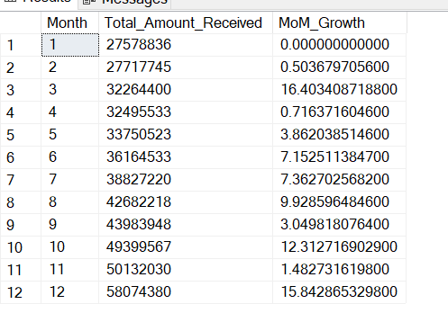

* **Avg Interest Rate**

select avg(int_rate)*100 as 'Average_Intrest_Rate'

from financial_loan;

* **MoM Average Interest Rate**

with cte as

(select month(issue_date) as 'Month',avg(int_rate)*100 as 'Average_Intrest_Rate'

from financial_loan

group by month(issue_date)

)

select *,

1.0 *(Average_Intrest_Rate -

lag(Average_Intrest_Rate,1,Average_Intrest_Rate) over(order by Month)) / lag(Average_Intrest_Rate,1,Average_Intrest_Rate) over(order by Month) * 100 as 'MoM_Growth'

from cte;

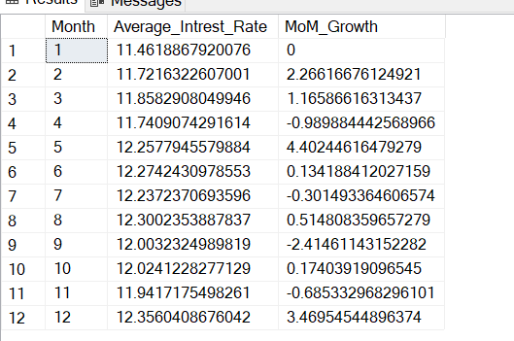

* **Average Debt-to-Income Ratio**

select avg(dti)*100 as 'Avg_Debt_to_Income_Ratio'

from financial_loan;

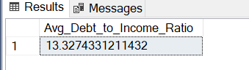

* **MoM Average Debt-to-Income Ratio**

with cte as

(select month(issue_date) as 'Month', avg(dti)*100 as 'Avg_Debt_to_Income_Ratio'

from financial_loan

group by month(issue_date)

)

select *,

1.0 *(Avg_Debt_to_Income_Ratio -

lag(Avg_Debt_to_Income_Ratio,1,Avg_Debt_to_Income_Ratio) over(order by Month)) / lag(Avg_Debt_to_Income_Ratio,1,Avg_Debt_to_Income_Ratio) over(order by Month) * 100 as 'MoM_Growth'

from cte;

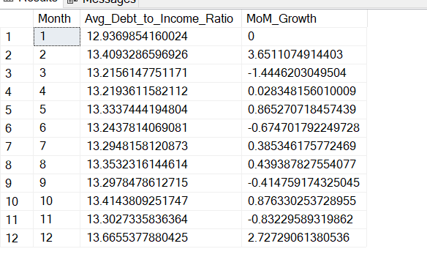

* **Good Loan Application %**

select 1.0 * count(id) / (select count(id) from financial_loan) * 100 as 'Good Loan Applications %'

from financial_loan

where loan_status in ('Fully Paid','Current')

* **Bad Loan Application %**

select 1.0 * count(id) / (select count(id) from financial_loan) * 100 as 'Bad Loan Applications %'

from financial_loan

where loan_status = 'Charged off';

* **Loan Status Analysis**

select loan_status,

count(id) as 'Total Applications',

sum(total_payment) as 'Total Amount Received',

sum(loan_amount) as 'Total Funded Amount',

avg(int_rate) * 100 as 'Avg Intrest Rate',

avg(dti)*100 as 'Avg Debt to Income Ratio'

from financial_loan

group by loan_status;

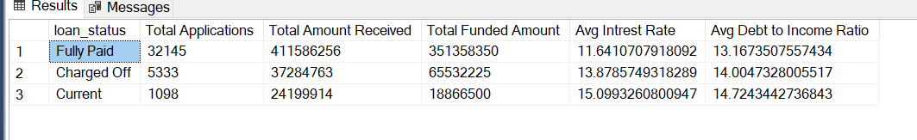

* **Monthly Analysis**

select month(issue_date) as 'Month',

count(id) as 'Total Applications',

sum(total_payment) as 'Total Amount Received',

sum(loan_amount) as 'Total Funded Amount',

avg(int_rate) * 100 as 'Avg Intrest Rate',

avg(dti)*100 as 'Avg Debt to Income Ratio'

from financial_loan

group by month(issue_date)

order by month(issue_date)

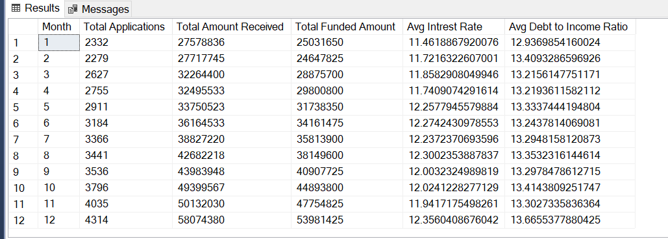

* **State Wise Analysis**

select address_state as 'State',

count(id) as 'Total Applications',

sum(total_payment) as 'Total Amount Received',

sum(loan_amount) as 'Total Funded Amount',

avg(int_rate) * 100 as 'Avg Intrest Rate',

avg(dti)*100 as 'Avg Debt to Income Ratio'

from financial_loan

group by address_state;

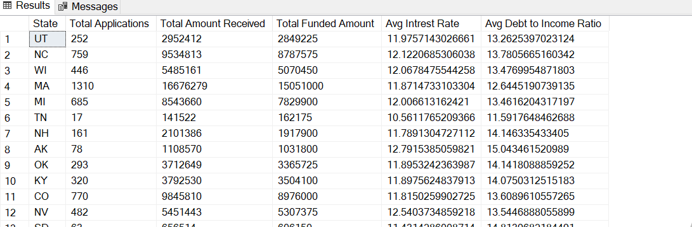

* **Loan Purpose Analysis**

select purpose as 'Loan Purpose',

count(id) as 'Total Applications',

sum(total_payment) as 'Total Amount Received',

sum(loan_amount) as 'Total Funded Amount',

avg(int_rate) * 100 as 'Avg Intrest Rate',

avg(dti)*100 as 'Avg Debt to Income Ratio'

from financial_loan

group by purpose;

